*How does the web work ?*

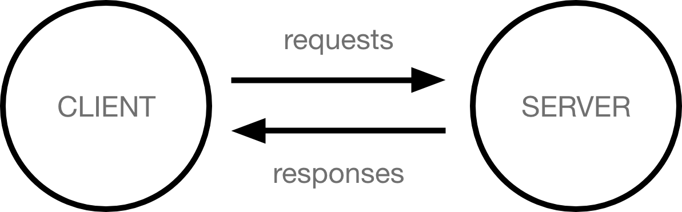

:What did you need to be web developer ?

* User experience (UX)
* User interface (UI)
* Visual design
* Coding languages including HTML and CSS
* Frontend web programing languages and skills such as JavaScript, Ajax and web animation techniques
* Backend web programing languages such as C# or Java, PHP and Ruby
* Design software like Photoshop and Illustrator and Sketch
* An understanding of SEO
* Web servers and how they function
* why do you choose web development?
* Web development has a number of pros: **High earning potential, opportunity for growth, and flexibility** are usually top of mind for most who get into the industry. Some of the challenges for people who pursue web development is the competitive nature of the job market